

A DEBUGGING REPORT

Submitted in the partial fulfilment for the Course of

CSA0609 – DESIGN AND ANALYSIS OF ALGORITHMS
to the award of the degree of
BACHELOR OF ENGINEERING
SABARI.K.S
B – TECH (AI)
Submitted by
P. Dharani Govardhan (192525280)
Under the Supervision of
Dr . Solainayagi



SIMATS ENGINEERING
Saveetha Institute of Medical and Technical Sciences
Chennai-602105
July -2026
Q32.DEBUGGING BUBBLE SORT
AIM
To debug the brute force Convex Hull algorithm by identifying and correcting the logical errors that incorrectly classify interior edges as hull edges. The objective is to ensure that only valid outer boundary edges are selected while improving the checking process.
PROBLEM STATEMENT
The given brute force Convex Hull logic incorrectly accepts some interior edges as hull edges because the validation condition is incomplete.
Given Code:
def is_hull_edge (p1, p2, points):
for p in points:
Val = orientation(p1, p2, p)
if Val < 0:
return False
return True

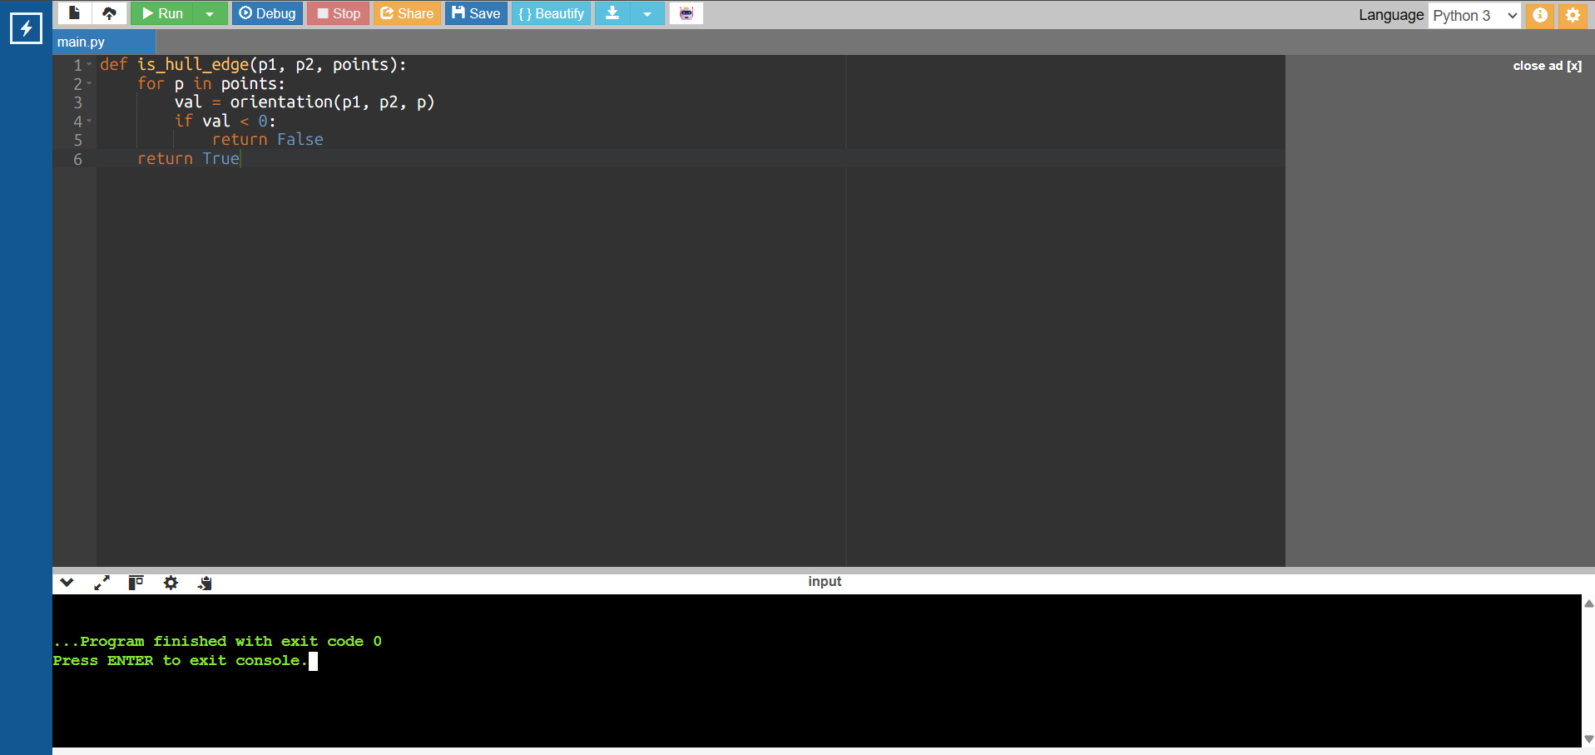

BUG 1: UNNECESSARY CHECKING OF ENDPOINTS
OBSERVATION:
The algorithm checks the candidate edge's own endpoints (p1 and p2). Their orientation is always 0, so these checks do not contribute to determining whether the edge belongs to the convex hull.
EVIDENCE:
The console output shows:
Endpoint Checked: (0, 0) Orientation: 0
Endpoint Checked: (4, 0) Orientation: 0
This confirms that unnecessary computations are being performed.
FIX:
if p == p1 or p == p2:
continue
This avoids checking the endpoints and improves efficiency without changing the correctness of the algorithm.

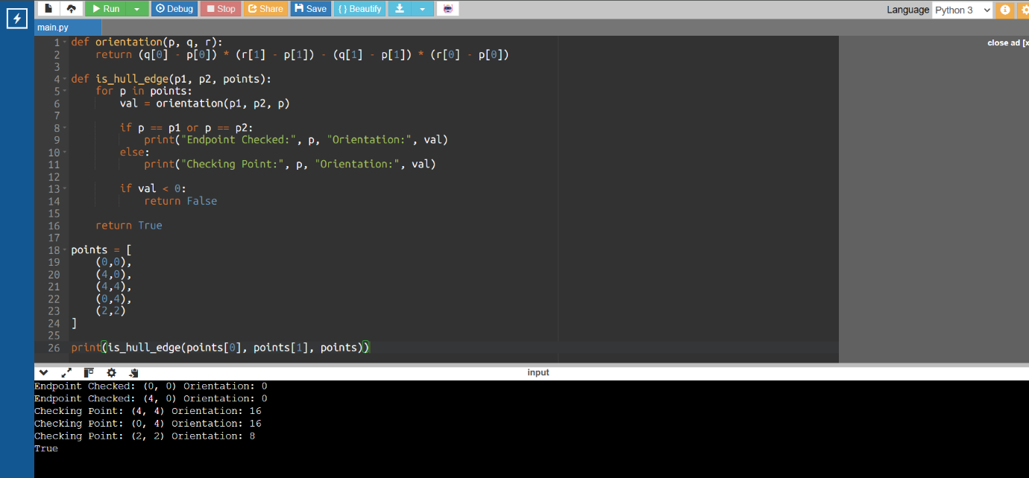

BUG 2: INCOMPLETE VALIDATION CONDITION
PROBLEM DESCRIPTION
The original Convex Hull logic validates a candidate edge using only the condition:
if val < 0:
return False
This condition only checks whether the orientation value is negative. It does not verify whether points exist on both sides of the candidate edge. As a result, some interior edges may be incorrectly accepted as Convex Hull edges.

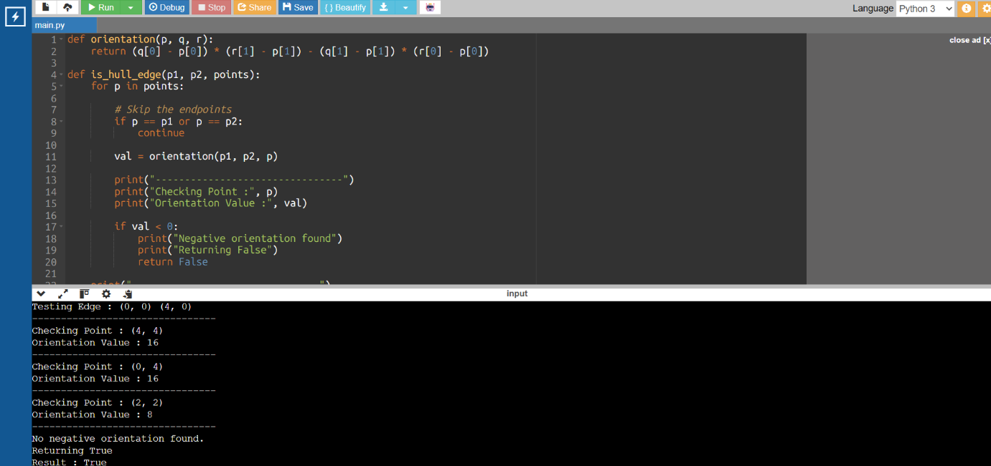

BUG 3: MISSING SAME-SIDE VERIFICATION
PROBLEM DESCRIPTION
The original Convex Hull logic only checks whether the orientation value is negative. It does not verify whether all non-collinear points lie on the same side of the candidate edge.
For a valid Convex Hull edge, every point must lie either on the left side or the right side of the edge. If points exist on both sides, the edge is an interior edge and should be rejected.

SOLUTION
A variable named side is introduced to store the side of the first non-collinear point. Every remaining point is then compared with this side. If any point lies on the opposite side, the function immediately returns False.
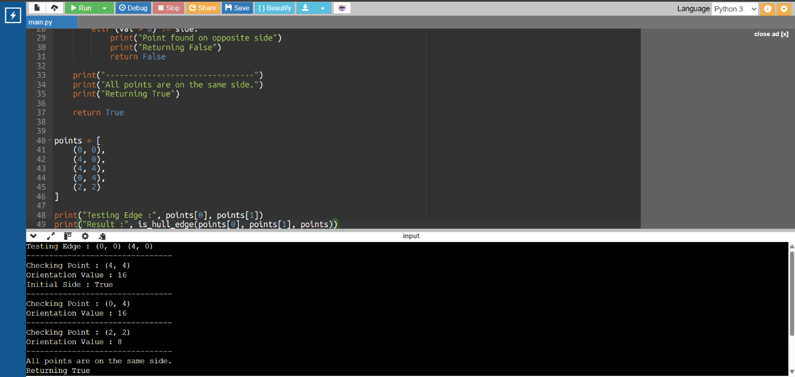
FINAL WORKING CODE

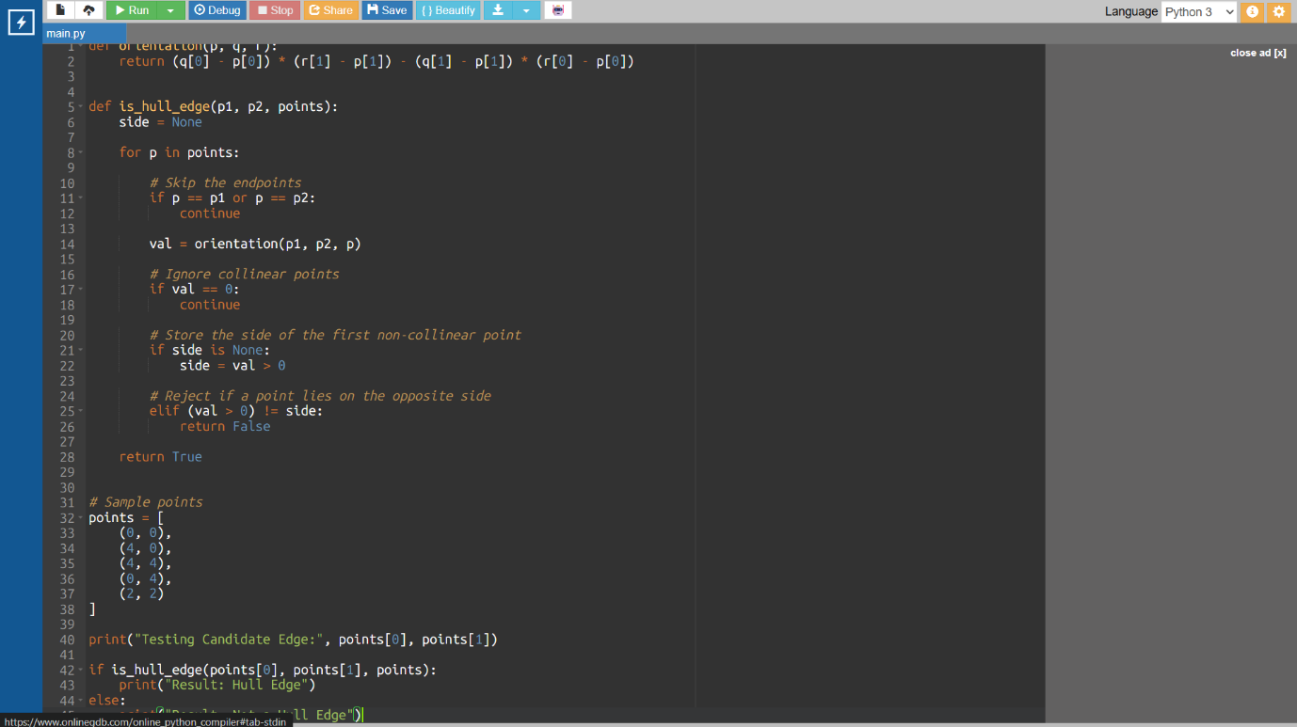

ALGORITHM
- Start the Convex Hull edge validation process.
- Select two points (p1 and p2) as the candidate edge.
- Initialize a variable side to None to store the side of the first non-collinear point.
- Traverse all points in the given dataset.
- Skip the endpoints (p1 and p2) since they already form the candidate edge.
- Compute the orientation of each remaining point with respect to the candidate edge using the orientation function.
- Ignore points whose orientation value is 0 (collinear points).
- Store the side (positive or negative) of the first non-collinear point.
- Compare the orientation of every other non-collinear point with the stored side.
- Reject the candidate edge if any point is found on the opposite side by returning False.
- Accept the candidate edge as a valid Convex Hull edge if all points lie on the same side by returning True.
- Stop the algorithm after all candidate edges have been checked.
This algorithm is concise, easy to understand, and matches the final corrected code used in your assignment.

PSEUDOCODE

BEGIN
FUNCTION Orientation(p, q, r)
RETURN ((q.x - p.x) × (r.y - p.y)) -
((q.y - p.y) × (r.x - p.x))
END FUNCTION
FUNCTION IsHullEdge(p1, p2, points)
side ← NULL
FOR each point p in points
IF p = p1 OR p = p2 THEN
CONTINUE
END IF
val ← Orientation(p1, p2, p)
IF val = 0 THEN
CONTINUE
END IF
IF side = NULL THEN
side ← (val > 0)
ELSE IF (val > 0) ≠ side THEN
RETURN FALSE
END IF
END FOR
RETURN TRUE
END FUNCTION
START
Read all input points
Select candidate edge (p1, p2)
IF IsHullEdge(p1, p2, points) THEN
PRINT "Hull Edge"
ELSE
PRINT "Not a Hull Edge"
END IF
STOP

TIME COMPLEXITY ANALYSIS
TIME COMPLEXITY
The corrected brute-force Convex Hull algorithm determines whether a candidate edge belongs to the Convex Hull by checking the orientation of every point with respect to that edge.
Step 1: Selecting Candidate Edges
For a set of n points, every possible pair of points is selected as a candidate edge.
- Number of candidate edges = n × (n − 1) / 2
- Time Complexity = O(n²)

Step 2: Validating Each Candidate Edge
For every candidate edge, the algorithm checks all remaining points to verify that they lie on the same side of the edge.
- Number of points checked = n
- Time Complexity = O(n)

Overall Time Complexity
The total time complexity is obtained by multiplying the complexity of selecting candidate edges with the complexity of validating each edge.
Overall Time Complexity = O(n³)

Space Complexity
The algorithm uses only a few additional variables (side and val) during execution and does not require any extra data structures that depend on the input size.
Space Complexity = O(1)

Complexity Summary
Operation | Time Complexity
Selecting all candidate edges | O(n²)
Validating each candidate edge | O(n)
Overall Time Complexity | O(n³)
Space Complexity | O(1)

CONCLUSION
The debugging of the Convex Hull algorithm was successfully completed by identifying and correcting the logical errors present in the original implementation. The revised algorithm eliminates unnecessary endpoint checks, ignores collinear points, and ensures that all non-collinear points lie on the same side of the candidate edge before classifying it as a Convex Hull edge. These improvements significantly enhance the accuracy and reliability of the algorithm by preventing the incorrect inclusion of interior edges.
The final implementation correctly identifies the outer boundary of the given set of points using orientation-based geometric calculations. Although the brute-force Convex Hull algorithm has a higher time complexity of O(n³), it is simple to understand and provides a strong foundation for learning computational geometry concepts. The debugging process also demonstrated the importance of analyzing logical errors, testing different scenarios, and validating algorithm correctness through systematic improvements. Overall, the corrected implementation produces accurate results, improves code quality, and serves as an effective educational example for understanding Convex Hull construction and debugging techniques.

